**ISYS 5453 Project**

**Group Members**

1. Jenny Glover: HTML & PHP expert
2. NiharikaKavuri: HTML/CSS & MySQL expert
3. Trishala Patne: HTML/CSS, MySQL & PHP expert

**Project Overview**

1. This project will create the UARKTweetbook.com website that allows students, faculty, alumni and staff of the University of Arkansas to post short messages, as well as to maintain a profile page about themselves. The vision for this site is to bring Razorback fans together and to provide a place to share all things hog wild!

**Account Usernames & Passwords**

1. Master
   1. Linux Account: uateam03 / UApass50
   2. MySQL: uateam03/uateam03
2. Website
   1. User: [kjackson@abc.com](mailto:kjackson@abc.com) / password
   2. Admin: [tp@abc.com](mailto:tp@abc.com) / admin

**Website Link – Letters of pages correspond with letters in next section**

1. [www.uarktweetbook.com](http://www.uarktweetbook.com)
   1. <http://130.184.26.149:1080/~uateam03/Welcome.php>
   2. <http://130.184.26.149:1080/~uateam03/AboutUs.php>
   3. <http://130.184.26.149:1080/~uateam03/Admin.php>
   4. <http://130.184.26.149:1080/~uateam03/MasterWall.php>
   5. <http://130.184.26.149:1080/~uateam03/editpostAdmin.php>
   6. <http://130.184.26.149:1080/~uateam03/editpost.php>
   7. <http://130.184.26.149:1080/~uateam03/deletepost.php>
   8. <http://130.184.26.149:1080/~uateam03/deletepostAdmin.php>
   9. <http://130.184.26.149:1080/~uateam03/RegistrationPage.php>
   10. <http://130.184.26.149:1080/~uateam03/MyHomePage.php>
   11. <http://130.184.26.149:1080/~uateam03/MyWall.php>
   12. <http://130.184.26.149:1080/~uateam03/ProfileInfo.php>
   13. <http://130.184.26.149:1080/~uateam03/EditProfile.php>
   14. <http://130.184.26.149:1080/~uateam03/Pageview.php>
   15. [http://130.184.26.149:1080/~uateam03/PageviewAdmin.php](http://130.184.26.149:1080/~uateam03/Pageview.php)

**Website Pages**

1. Welcome page
   1. Welcome photos
   2. About Us
   3. Log-in
   4. Register
2. About Us page
   1. Website overview
   2. About the staff with pictures
   3. Contact
3. Admin page
   1. Display names of all users
      1. Delete a user option
      2. Edit / delete posts
      3. Search user profile
      4. Ads
4. Registration page (from Welcome page, ‘Register’ selection)
   1. Create user profile
5. Master message page
   1. Links
   2. Display all messages from all public users
   3. Ads
6. Individual messages page (for the user)
   1. Links
   2. Own messages
   3. Ability to post, edit, delete messages (will post here and main message page)
   4. Ads
7. Individual profile page (for the user)
   1. Links
   2. Profile info – personal view
   3. Ads
8. Individual profile edit page
   1. Links
   2. Edit button
   3. All fields changeable except username
   4. Ads
9. Individual profile/messages page (for the viewer)
   1. Links
   2. Profile info – public view
   3. That user’s messages
   4. Ads
10. Site-wide elements
    1. Left Navigation Bar
       1. Master messages page (“Home”)
       2. Individual profile/messages page (“My Wall”)
       3. Search for a user
       4. Uark website (<http://www.uark.edu/>)
       5. UAConnect (<https://uaconnect.uark.edu/>
       6. Uark Athletics (<http://www.arkansasrazorbacks.com/>)
       7. Uark BB (<https://learn.uark.edu/>)
    2. Right Advertisement Bar
    3. Log-in/Logout
    4. UATweetBook.com footer

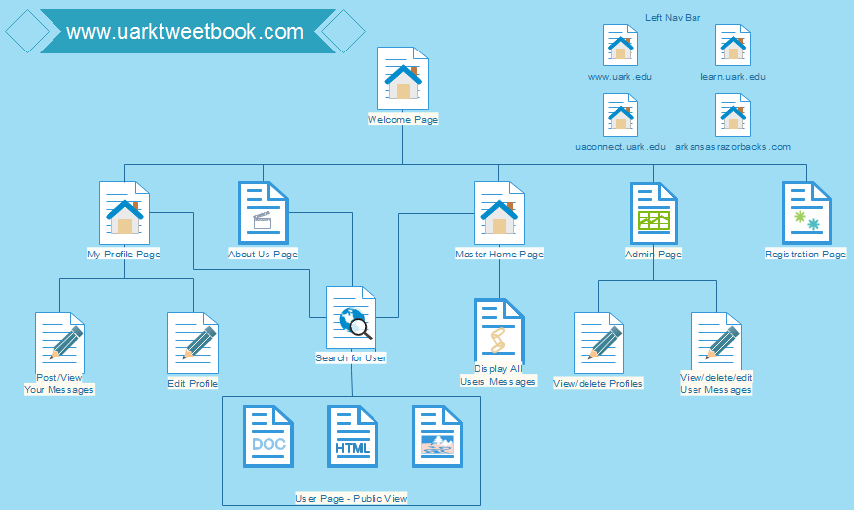

**Database Tables**

1. User table (create table UserInfo( Username varchar(20) primary key, Passwordvarchar(20) not null, DateOfBirth date, DisplayName varchar(20) not null, IndOrBusvarchar(20), Gender varchar(10), Email varchar(50), City varchar(30), State varchar(20), Country varchar(20),RelStatus varchar(20), PubOrPrivarchar(20) not null, ProfilePicture varchar(50), UserOrAdmin varchar(10) )ENGINE=InnoDB;
   1. Username
   2. Password
   3. Date of birth
   4. Display name
   5. Individual or business?
   6. Gender
   7. Email
   8. City
   9. State
   10. Country
   11. Relationship status
   12. Public or private?
   13. Picture
   14. Administrative rights?
2. Message tables(create table Messages( MessagesIdint not null auto_increment primary key, Username varchar(20), constraint FK_UserMessagesforeign key (Username)references UserInfo(Username), Message varchar(140), Time timestamp )ENGINE=InnoDB;
   1. Messages ID
   2. Username
   3. Message
   4. Time stamp

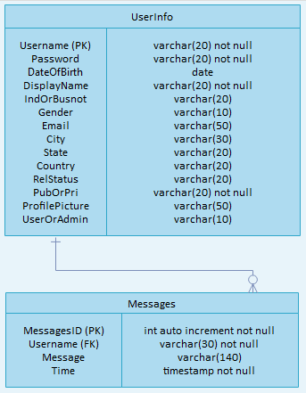

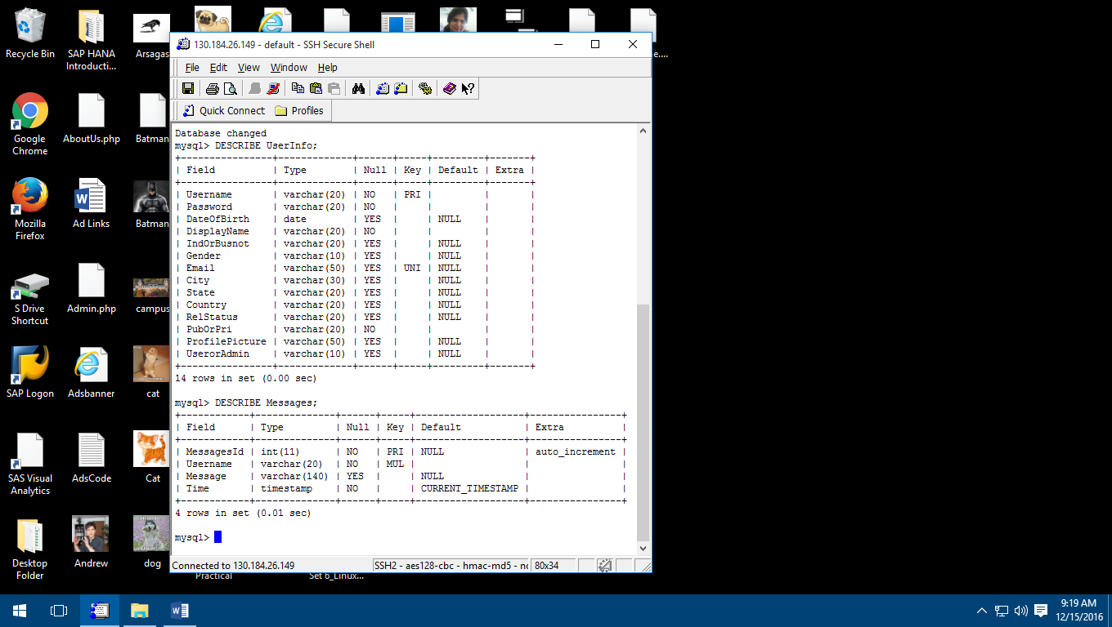

**Key Features of Website**

1. User
   1. Ability to register to be a user of the site
   2. Ability to log-in
   3. Ability to post messages
      1. Edit own messages
      2. Delete own messages
   4. Ability to view profiles(Only Public profiles can be viewed)
   5. Ability to search for profiles
   6. Ability to view messages
   7. Ability to edit own profile
      1. Set own profile to private
2. Admin
   1. Ability to authenticate user(s)
   2. Ability to view all users
   3. Ability to delete user profiles
   4. Ability edit/delete user messages

(After editing/deleting messages, page will redirect to admin home page. But post will get edited/deleted at backend. Admin can go to user profile and check)

**References**

* <http://www.w3schools.com/php/php_mysql_intro.asp>
* <http://www.htmlgoodies.com/beyond/javascript/article.php/3881826/JavaScript-Tutorial-Adding-Rotating-Images-to-Your-Web-Site.htm>
* <http://getbootstrap.com/>
* <http://onf.coop>
* <http://www.thefarmerstablecafe.com>
* <http://arsagas.com>
* <http://www.nwaescaperoom.com>
* <https://khanaindiangrill.com>
* <http://stonemillbread.net>
* <http://puritancoffeebeer.com>
* <https://www.fayettechill.com>
* <http://www.w3schools.com/css/>
* <http://www.w3schools.com/bootstrap/default.asp>
* <http://www.databasejournal.com/features/mysql/article.php/2248101/Referential-Integrity-in-MySQL.htm>